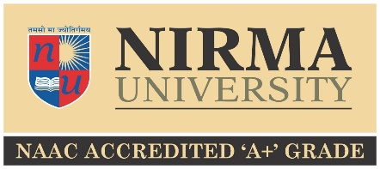
Nirma University
Students’ Welfare Board
LAWN TENNIS

Inter Institute Sports Competition 2022-23

Name of Institute : _________________ Faculty Coordinator: ________________________________
Mobile. No: _______________ Email-Id: __________________________ Ext No.: _____________

SINGLES
Sr. No. | Full Name of Participant | Roll No | Gender | UG/  PG | Mobile | Email
1 |  |  | M
1 |  |  | F

DOUBLES
Sr. No. | Full Name of Participant | Roll No | Gender | UG/  PG | Mobile | Email
1 |  |  | M
2 |  |  | M
1 |  |  | F
2 |  |  | F

MIXED DOUBLES
Sr. No. | Full Name of Participant | Roll No | Gender | UG/  PG | Mobile | Email
1 |  |  | M
2 |  |  | F

Date: - _____/ _____/ 2022

________________________ _______________
(Sports Coordinator Signature) Stamp/Seal of the Institute (Director Signature)

Last date for submission of entry: October 15, 2022

